A comprehensive analysis of financial performance: Insights from the leading banks

**INTRODUCTION OVERVIEW:**

The banking industry world- wide is being transformed. The global forces for change include technological innovation; the deregulation of financial services at the national level and opening-up to international competition; and - equally important - changes in corporate behavior, such as growing disintermediation and increased emphasis on shareholder value. In addition, recent banking crises in Asia and Latin America have accentuated these pressures. The banking industries in central Europe and Latin America have also been transformed as aresult of privatizations of state-owned banks that had dominated their banking systems in the past. In this project we are trying to analysis the bank related data and to extract some insights from the data using Business Intelligence tools. To Extract the Insights from the data and put the data in the form of visualizations, Dashboards and Story we employed Tableau tool.

**PURPOSE:**

The financial analysis aims to analyze whether an entity is stable, liquid, solvent, or profitable enough to warrant a monetary investment. It is used to evaluate economic trends, set financial policies, build long-term plans for business activity, and identify projects or companies for investment.

In bank credit analysis, banks consider and evaluate every loan application based on merits. They check the creditworthiness of every individual or entity to determine the level of risk that they subject them self by lending to an entity or individual.

It demonstrates the interrelationship between the income statement and balance sheet and describes the risk and return trade-off underlying management

decisions. Data are provided that compare the performance characteristics of small banks versus large banks and differentiate between high and low performers.

Broadly speaking, the objectives of the analysis are to apprehend the information contained in financial statements with a view to know the weaknesses and strengths of the firm and to make a forecast about the future prospects of the firm thereby, enabling the analysts to take decisions regarding the operation

It provides internal and external stakeholders with the opportunity to make informed decisions regarding investing. Financial statement analysis also provides lending institutions with an unbiased view of a business's financial health, which is helpful for making lending decisions.

Financial statement analysis is a specific study done by a business into its own accounts, so that it can make important and informed decisions about how the company might proceed. Business collaborators rely on this type of analysis to give them an idea of the business's value and how their investment is performing.

This is one of the most important financial ratios for calculating profit, looking at a company's net earnings minus dividends and dividing this figure by shareholders equity. The result tells you about a company's overall profitability, and can also be referred to as return on net worth.Fundamental analysis studies the various financial, economic and industrial parameters that influence the risk-return of securities and helps in investment decision making.

With the help of fundamental analysis, investors can track the past performance, recent changes and future prospects of the banking sector.

Banking business analysts review various types of banking transactions on a daily basis. They examine cash flow and financial statements, generate summary reports, monitor rate changes, develop financial models, and complete forecasting reports for financial projects.

# PROBLEM DEFINITION & DESIGN THINKING:

**EMPATHY MAP:**

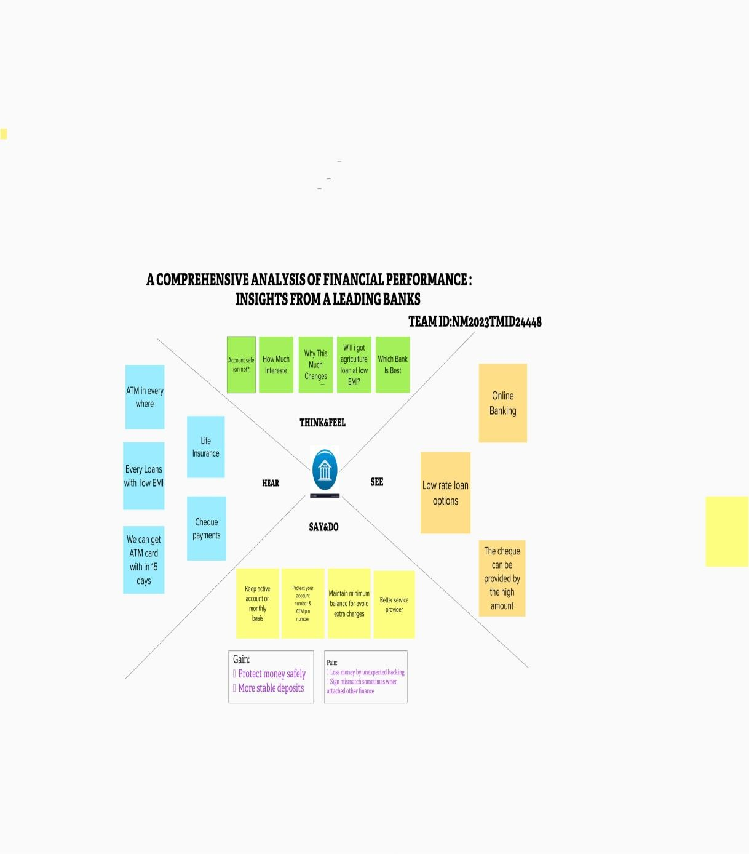

# IDEATION & BRAINSTROMING MAP:

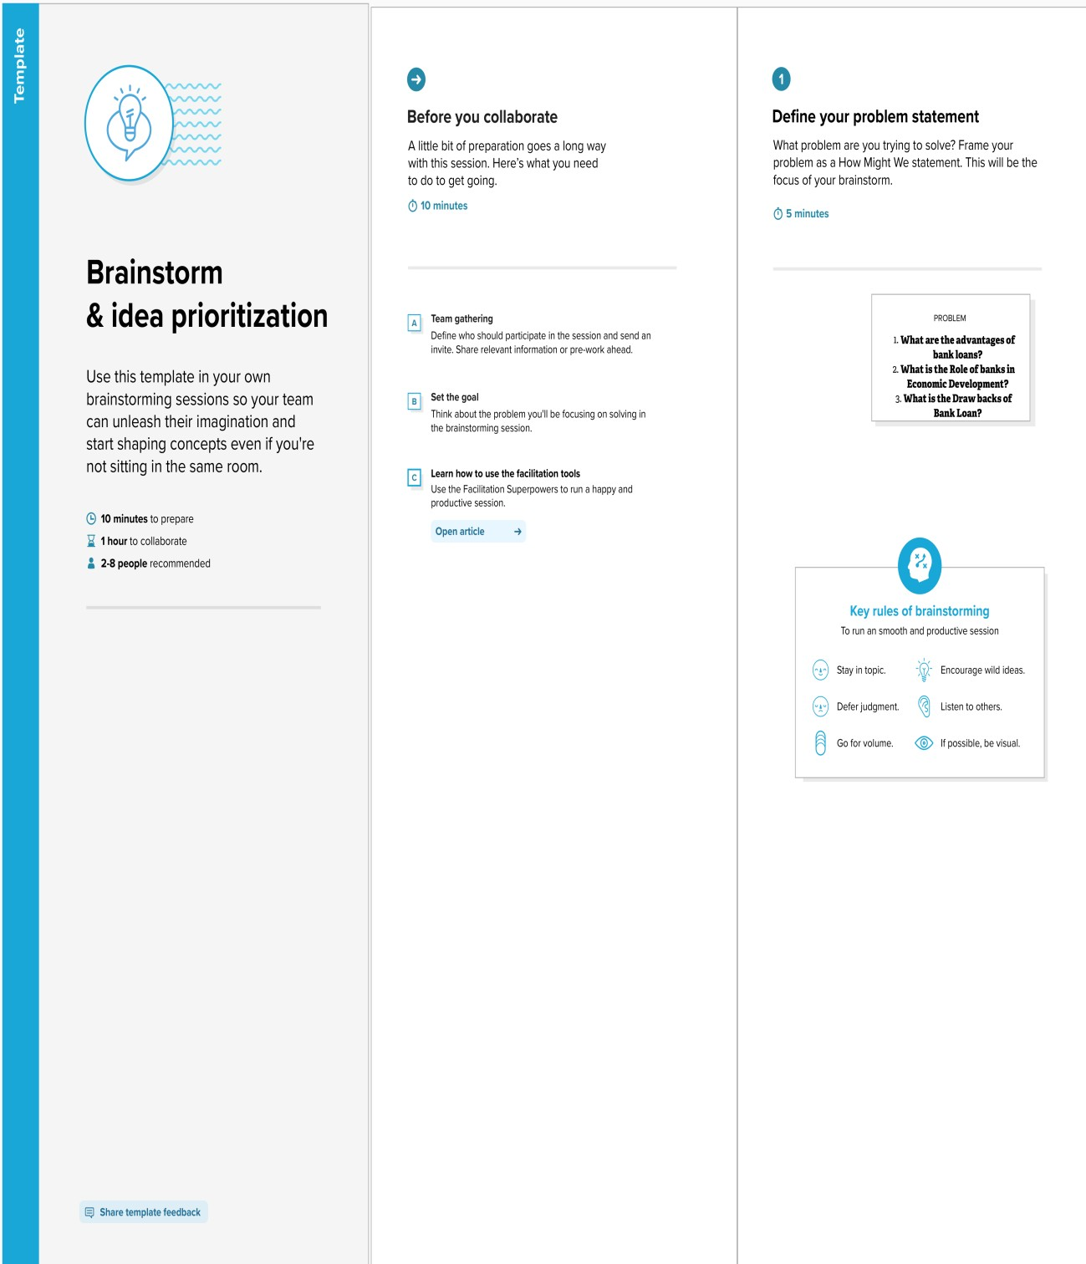

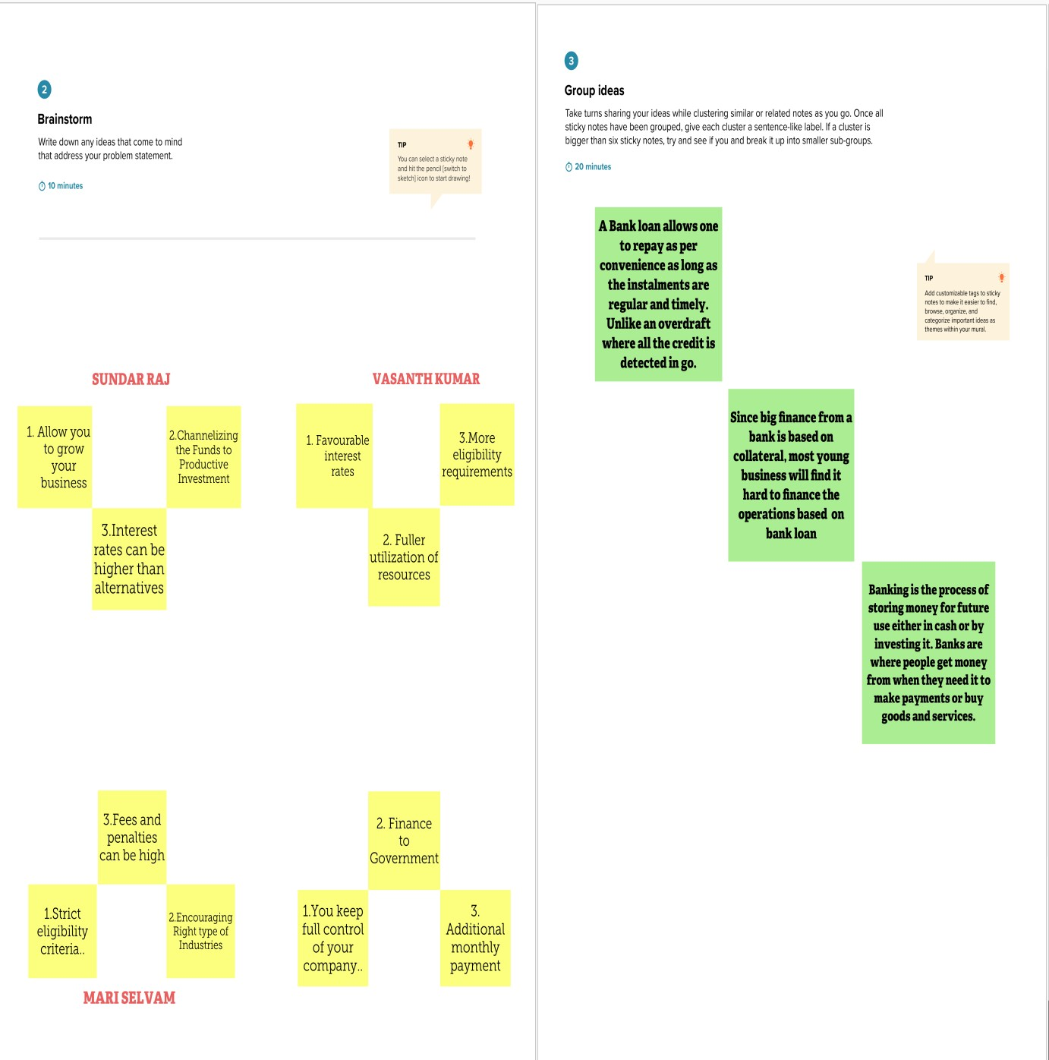

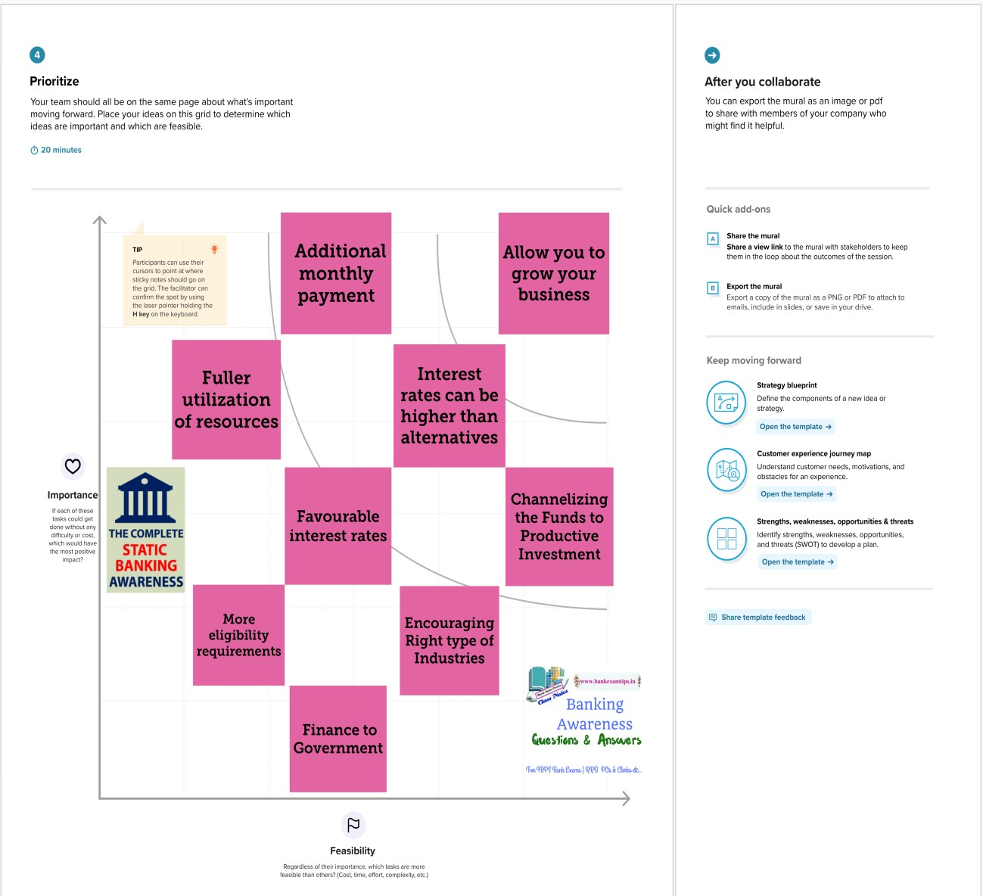

**RESULT:**

# TOP BANKS ACCORDING TO TOTAL ASSESTS:

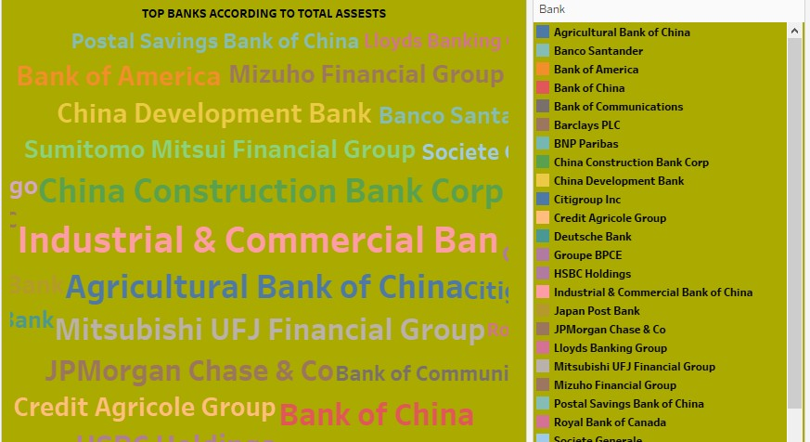

**TOP 10 COUNTRIES WITH ASSESTS PROPORTION:**

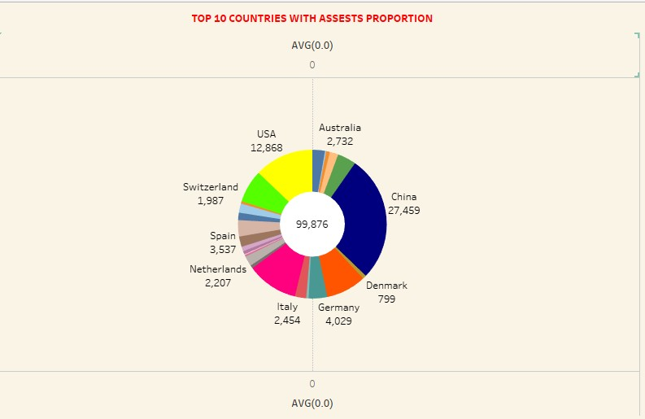

**TOTAL ASSESTS ANALYSIS ACCORDING TO YEAR AND QUARTER:**

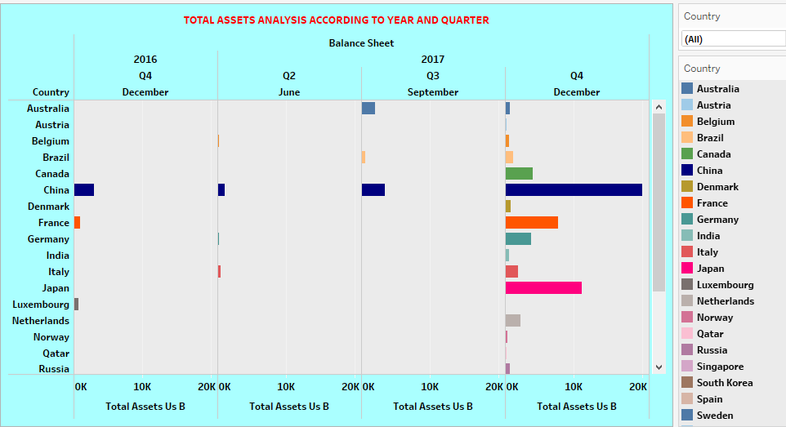

**COUNTRY WITH TOTAL ASSESTS USING FUNNEL CHART:**

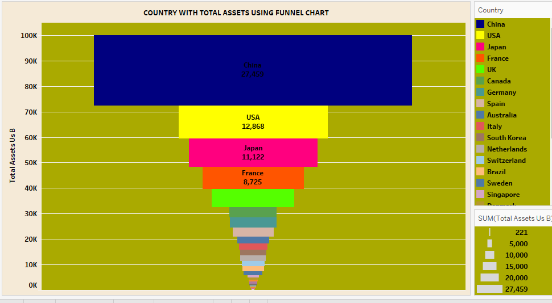

**TOP BANKS ACCORDING TO BANKS AND ASSESTS:**

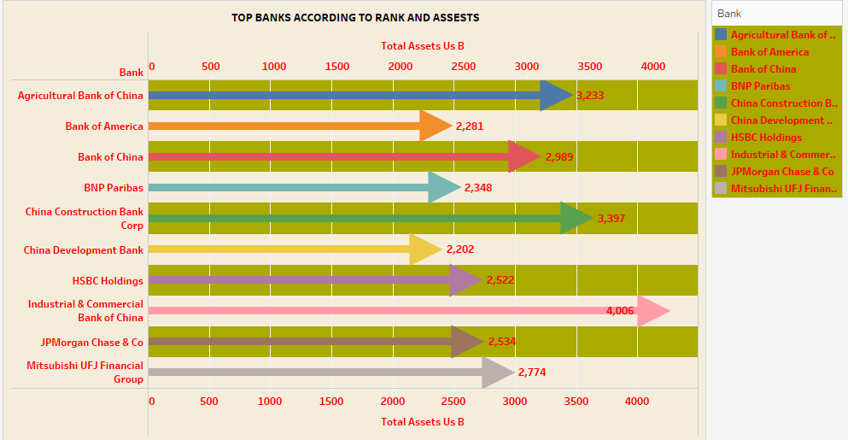

**TOP BANKS ACCORDING TO COUNTRY BASED ON TOTAL ASSESTS:**

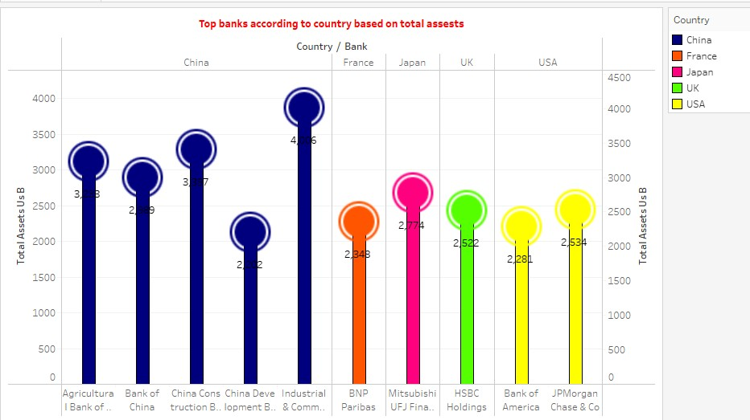

# ADVANTAGES OF BANK ANALYSIS:

* provides internal and external stakeholders with the opportunity to make informed decisions regarding investing
* help fund managers make future business decisions
* helps the management to judge the overall as well as segment wise operational efficiency of the business.
* provide a snapshot of a corporation's financial health, giving insight into its performance, operations, and cash flow.
* asset management, liquidity, debt management, market value, the financial performance of the various departments, and profitability of the business parts

**DISADVANTAGES OF BANK ANALYSIS:**

There are some significant limitations of financial analysis which are the following: The financial analysis does not consider cost-price level changes. The financial analysis is ambiguous if the prior knowledge of the changes in accounting procedure followed by the company is not known.

Problems with inputs that will influence also the quality of the output from the financial analysis: financial statements are prepared with a certain time lag (usually up to 6 months), the current situation can already be different

# APPLICATIONS:

* helps finance teams gather the information needed to gain a clear view of key performance indicators (KPIs)
* track a student's usage of learning materials and tools to identify potential issues or gaps, and

offer an objective evaluation of learning materials and tools.

* the Creditor Institution to which the first application is made by the debtor requesting restructuring of its debts within the scope of the Framework Agreement,

# CONCLUSION:

* **TOP BANKS ACCORDING TO TOTAL ASSESTS**

# TOP 10 COUNTRIES WITH ASSESTS PROPORTION

* **TOTAL ASSESTS ANALYSIS ACCORDING TO YEAR AND QUARTER**
* **COUNTRY WITH TOTAL ASSESTS USING FUNNEL CHART:**
* **TOP BANKS ACCORDING TO BANKS AND ASSESTS**
* **COUNTRY WITH TOTAL ASSESTS USING FUNNEL CHART**
* **TOP BANKS ACCORDING TO COUNTRY BASED ON TOTAL ASSESTS**

# FUTURE SCOPE:

**The future of investment banking is expected to be shaped by technological advancements, changes in regulatory environments, and evolving customer needs. The increasing use of automation and fintech solutions is expected to drive efficiency and cost savings in investment banking operations.**

**Successful banks of 2030 will master data-driven customer experience across channels, underpinned by artificial intelligence and robotic automation. Consumers are becoming far more aware of the value of their personal data and the importance of keeping it safe and secure.**

Dashboard 1:

[https://public.tableau.com/views/Dashboard1Vasanth/Dashboard1?:language=en-](https://public.tableau.com/views/Dashboard1Vasanth/Dashboard1?%3Alanguage=en-US&%3Adisplay_count=n&%3Aorigin=viz_share_link) [US&:display_count=n&:origin=viz_share_link](https://public.tableau.com/views/Dashboard1Vasanth/Dashboard1?%3Alanguage=en-US&%3Adisplay_count=n&%3Aorigin=viz_share_link)

Dashboard 2:

[https://public.tableau.com/views/Dashboard2Vasanth/Dashboard2?:language=en-](https://public.tableau.com/views/Dashboard2Vasanth/Dashboard2?%3Alanguage=en-US&%3Adisplay_count=n&%3Aorigin=viz_share_link) [US&:display_count=n&:origin=viz_share_link](https://public.tableau.com/views/Dashboard2Vasanth/Dashboard2?%3Alanguage=en-US&%3Adisplay_count=n&%3Aorigin=viz_share_link)

Story:

[https://public.tableau.com/views/StoryVasanth/Story1?:language=en-](https://public.tableau.com/views/StoryVasanth/Story1?%3Alanguage=en-US&%3Adisplay_count=n&%3Aorigin=viz_share_link) [US&:display_count=n&:origin=viz_share_link](https://public.tableau.com/views/StoryVasanth/Story1?%3Alanguage=en-US&%3Adisplay_count=n&%3Aorigin=viz_share_link)

Web Application: file:///C:/Users/karna/Downloads/Day/index.html